

2023

Year 11 Integrated Science – Unit 2: Physical Science

Task 10: Extended Response

|  |  |  |  |
| --- | --- | --- | --- |
| **Assessment Type:** |  | Name: |  |
| Test |  |
| **Duration & Conditions:**  Test conditions |  | Teacher: |  |
| 50 minutes |  |  |  |
| **Assessment weighting:**  15% of year mark |  | Date: |  |

|  |  |
| --- | --- |
| **Section** | Marks |
| **Total Mark** | $${}/{24}$$ |

I acknowledge that all the information contained in this task is my own work and not taken from other sources. If other sources have been used, they have been acknowledged in my references.

___________________________________

(Student Signature)

Please see SEQTA for Teacher feedback and comments

**Introduction**

You are part of an elite team of young aerospace engineers at AstroLabs, a startup aiming to revolutionise space travel. The company has been working on a new rocket, but the team is divided over which nose cone design to use. Two prototypes have been created: one with a flat nose cone, one with a curved nose cone.

**Nose Cone 1 Nose Cone 2**

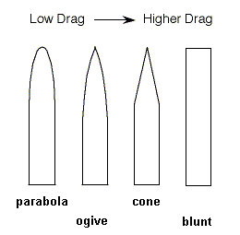

**Question 1 (8 marks)**

Compare Nose Cone 1 and Nose Cone 2. Explain how the shape of the nose cone would affect the flight of the rocket. Use relevant physical principles and Newton’s Laws in your explanation.

**Question 2 (4 marks)**

The design team is debating whether to include fins on the rocket.

Make a recommendation for whether fins should be included in the design. Explain the purpose of fins in rocket design and how their presence or absence could affect the rocket’s flight.

**Question 3 (6 marks)**

The scientists are trying to decide between different rocket fuels. List 3 factors that can influence which rocket fuel type to select and explain why it is important.

|  |  |
| --- | --- |
| **Factor** | **Explanation** |
|  |  |
|  |  |
|  |  |

**Question 4 (6 marks)**

The scientists are considering editing the rocket design to include multiple stages. Instead of a single engine, the rocket will contain multiple engines. After the fuel for the first engine is consumed, that engine and the fuel tank are disconnected from the rocket and ejected. A secondary engine starts, fuelled by a secondary fuel tank.

Explain how the use of multiple stages could increase the maximum height reached by the rocket. Support your answer with your knowledge of Newton’s Laws.

**END OF ASSESSMENT**